**FREE SENIOR PASS**

**65 OR OLDER?**

**GWINNETT COUNTY RESIDENT?**

**VALID EMAIL ADDRESS?**

**APPLY FOR YOUR FREE SENIOR PASS FOR FREE ENTRY INTO GWINNETT COUNTY PUBLIC SCHOOLS FINE ARTS AND SPORTING EVENTS.**

(Region Play & State Playoffs not included)

**SCAN THE QR CODE BELOW AND FOLLOW THE**

**INSTRUCTIONS TO HAVE YOUR PASS**

**MAILED TO YOU.**

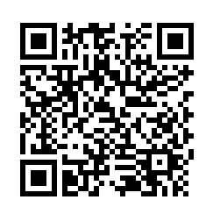

Or email [Joann.Baker@gcpsk12.org](mailto:Joann.Baker@gcpsk12.org) to receive a link to apply for your Senior Pass